EH100594 – Document Editing via a browser
- Install TxTextControl Service:
- Verify Installation
Ensure that TX Text Control is not installed on the portal server. If it is, uninstall it via Control Panel.
- Check Existing Services
Open Services and confirm that TX TextControl 32.0 Service is not listed. If it is:
Stop the service.
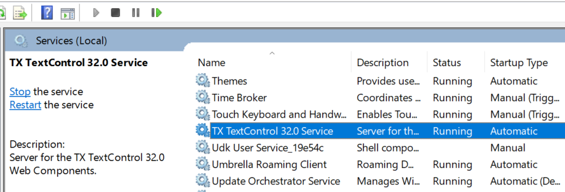
Delete it using the command below (run Command Prompt as administrator):
sc.exe delete "TX TextControl 32.0 Service"
- Deploy Files
Extract the ZIP file and copy the folder TX Text Control 32.0.NET Server for ASP.NET to your desired location, preferably C:\Program Files:
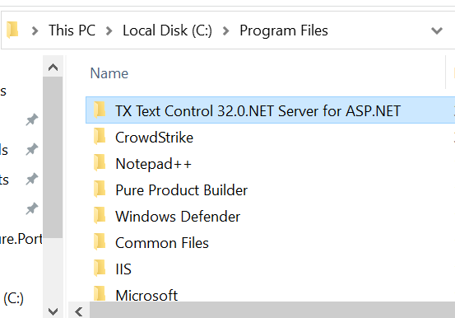
- Register the Service
Navigate to the folder and run the command file RegisterService.cmd as administrator.

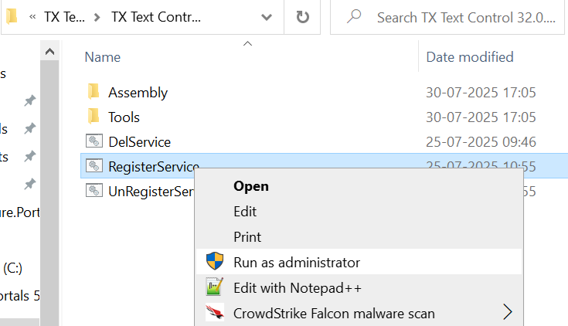

Note: Manual Registration (if script fails due to security)
If system restrictions prevent the script from running, open Command Prompt with administrative rights and execute:
cd "C:\Program Files\TX Text Control 32.0.NET Server for ASP.NET\Assembly"
txregwebsvr.exe /i /e /w

- Verify Setup
Confirm that the service TX TextControl 32.0 Service is now running successfully.


Following successful installation, the below changes are required within Pure Insurance
- Configuration changes in Pure
- Changes in web.config
- Add a new tag “EnableTXTextControl” within the “Portal” tag.
This will need to be set to either “True” or “False”.
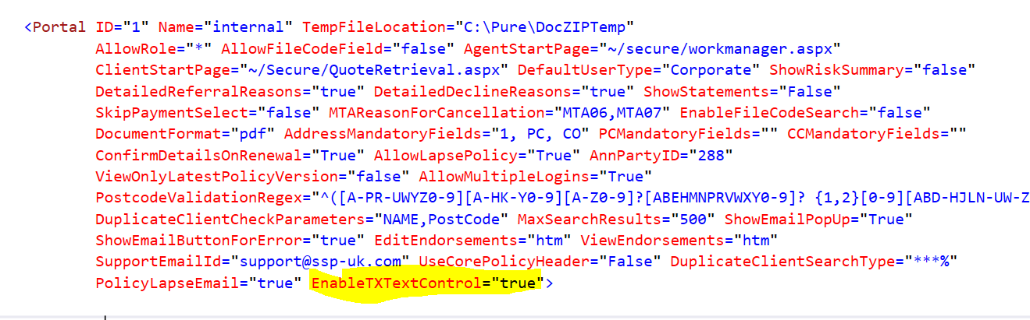
- Add 2 new names within the <handlers> tag.
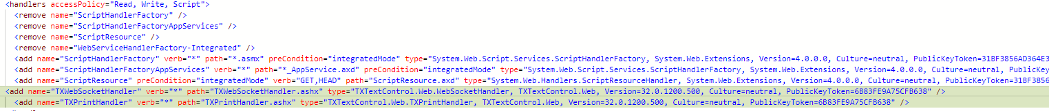
Code Snippet:
<add name="TXWebSocketHandler" verb="*" path="TXWebSocketHandler.ashx" type="TXTextControl.Web.WebSocketHandler, TXTextControl.Web, Version=32.0.1200.500, Culture=neutral, PublicKeyToken=6B83FE9A75CFB638" />
<add name="TXPrintHandler" verb="*" path="TXPrintHandler.ashx" type="TXTextControl.Web.TXPrintHandler, TXTextControl.Web, Version=32.0.1200.500, Culture=neutral, PublicKeyToken=6B83FE9A75CFB638" />

- Change in customized pages
If you have a customized DocumentManager.ascx.vb page, the following changes will be required. This is to be done within the sub ‘grdDocuments_RowCommand’

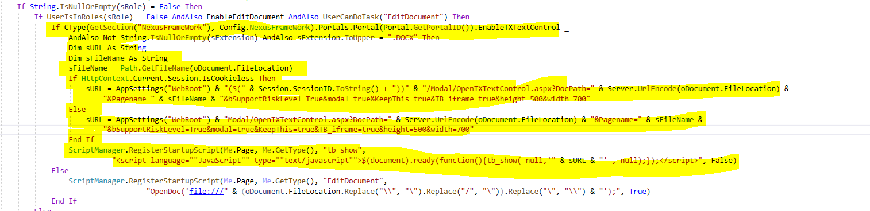

Code Snippet:
Protected Sub grdDocuments_RowCommand(ByVal sender As Object, ByVal e As System.Web.UI.WebControls.GridViewCommandEventArgs) Handles grdDocuments.RowCommand

…..
Dim sExtension As String = Path.GetExtension(oDocument.FileLocation)
If String.IsNullOrEmpty(sRole) = False Then
If UserIsInRoles(sRole) = False AndAlso EnableEditDocument AndAlso UserCanDoTask("EditDocument") Then
If CType(GetSection("NexusFrameWork"), Config.NexusFrameWork).Portals.Portal(Portal.GetPortalID()).EnableTXTextControl AndAlso Not String.IsNullOrEmpty(sExtension) AndAlso sExtension.ToUpper = ".DOCX" Then
Dim sURL As String
Dim sFileName As String
sFileName = Path.GetFileName(oDocument.FileLocation)
If HttpContext.Current.Session.IsCookieless Then
sURL = AppSettings("WebRoot") & "(S(" & Session.SessionID.ToString() + "))" & "/Modal/OpenTXTextControl.aspx?DocPath=" & Server.UrlEncode(oDocument.FileLocation) & "&Pagename=" & sFileName & "&bSupportRiskLevel=True&modal=true&KeepThis=true&TB_iframe=true&height=500&width=700"
Else
sURL = AppSettings("WebRoot") & "Modal/OpenTXTextControl.aspx?DocPath=" & Server.UrlEncode(oDocument.FileLocation) & "&Pagename=" & sFileName & "&bSupportRiskLevel=True&modal=true&KeepThis=true&TB_iframe=true&height=500&width=700"
End If
ScriptManager.RegisterStartupScript(Me.Page, Me.GetType(), "tb_show", "<script language=""JavaScript"" type=""text/javascript"">$(document).ready(function(){tb_show( null,'" & sURL & "' , null);});</script>", False)
Else
ScriptManager.RegisterStartupScript(Me.Page, Me.GetType(), "EditDocument", "OpenDoc('file:///" & (oDocument.FileLocation.Replace("\\", "\").Replace("/", "\")).Replace("\", "\\") & "');", True)
End If
…..
End Sub

